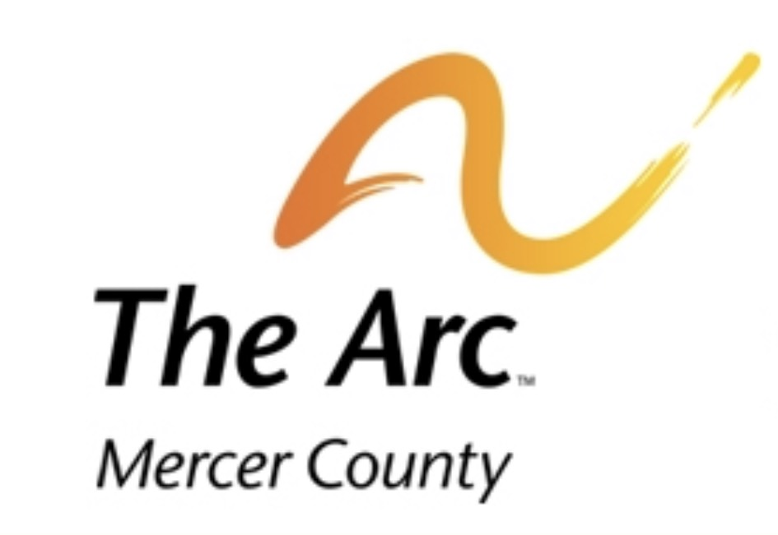  Fun in the Sun Summer Camp  Fun in the Sun Summer Camp is a non-profit organization affiliated with The Arc of Mercer County. This month-long day camp is designed for school-age children (ages six to 21). Camp takes place during the month of July each year at various sites in Mercer County and western Pennsylvania.  For more information, contact Mike Jones at 724-981-8325.  Fun in the Sun Website: http://ww3.funinthesunsummercamp.net/  The Arc of Mercer County Location and Contact Information  850 N. Hermitage Road, Hermitage, PA 16148  Phone: 724-981-2950 • fax: 724-981-1877 | Mercer County has a variety of services located across its borders that ensure the welfare, education, and needs of an individual is met.  Other Services:  - Association for Children With Learning Disabilities (ACLD)  28 Pine Street Sharon, PA 16146  - Children’s Aid Society of Mercer County  350 West Market Street P.O. Box 167 Mercer, PA 16137  - Community Counseling Center of Mercer County  2201 E. State Street Hermitage, PA 16148 or 406 North Buhl Farm Drive Hermitage, PA 16148  - Diversiﬁed Family Services 5454 E. State Street Sharon, PA 16146  - Grove City YMCA 543 East Main Street Grove City, PA 16127  Phone:  Email:  Web: | Mercer County Helpful Services  - By: Justin Walter
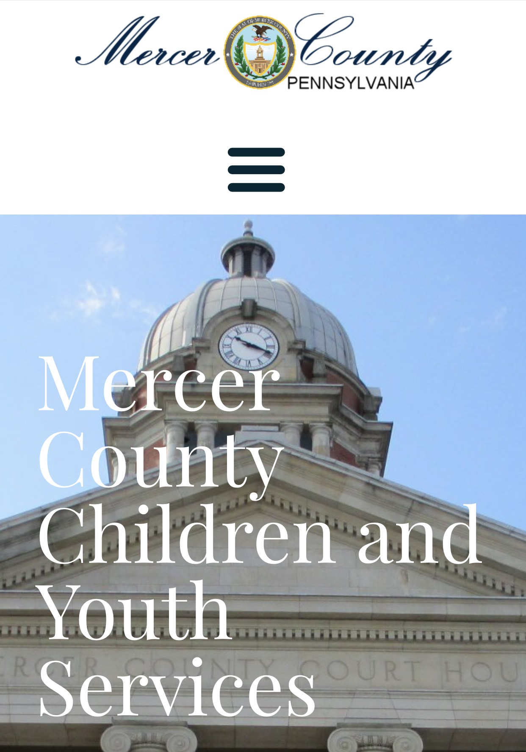  Mercer County Children and Youth Services  MCCYS provides services and assistance to families and children to enable children to remain safely within their own homes and to prevent family disruption and the need for child placement.  Temporary safe care and supportive services in the most family-like setting possible for children in need of placement outside of the home.  Contact Information:  8425 Sharon-Mercer Road Mercer, PA 16137  Telephone: 724-662-2703  Office Hours: Monday - Friday: 8:30 am - 4:30 pm | 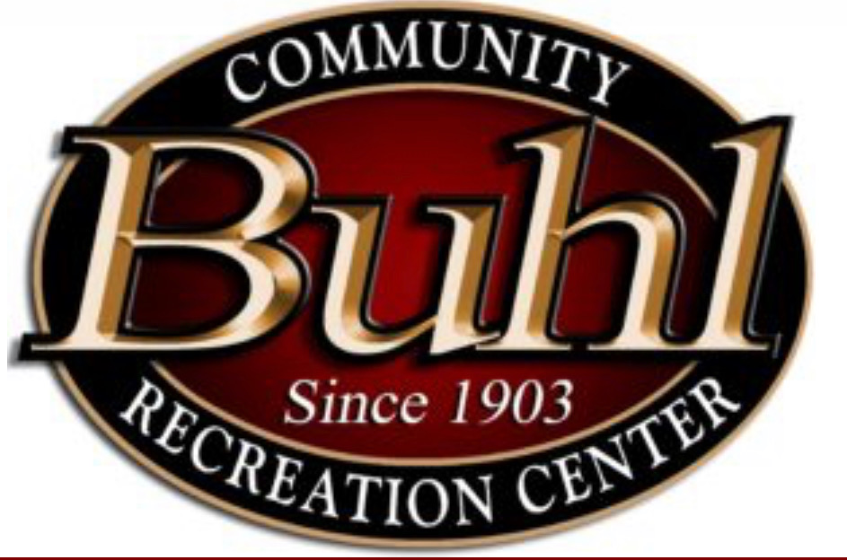Buhl Club  The Buhl Club Child Development Center provides exemplary early education and child care for families, by offering a safe, secure program that promotes the social, physical, cognitive and language development for ALL children. The Buhl Club provides PA State Licensed Child Care, Preschool and School Age Programs, 12 months to 12 yrs.  Location: 28 North Pine Street Sharon, PA 16146  Telephone: 724-981-3700 Office Hours: Monday – Friday: 9:30 am - 9:00 pm Saturday: 9:30 am - 5:00 pm  Website: www.fh buhlclub.org  Development Center Contact:  Kelly Caruso, Director  Phone: 724-981-3700 ext. 110 |  Email: kcaruso@fhbuhlclub.org | The Mercer County Behavioral Health Commission (MCBHC)  Behavioral Health is a private, non-profit organization that assists individuals with mental health, and intellectual disability needs, along with other issues to ensure the best quality of life for the individual.  They also provide needs assessments, service planning, linkage to community supports and resources, service coordination and monitoring for individuals.  Contact Information  8406 Sharon-Mercer Road  Mercer, PA 16137-3138  Next to McCandless FORD on RT 62.  Phone: 724-662-1550  Fax: 724-662-1557  Email: www.mercercountybhc.org

