Story Bird
Storybird.com
Storybird has simple tools to help you build books in minutes. Storybird has free class tools to manage students creations, issue assignments, and build a library of beautiful stories. The combination of art and word inspires the most reluctant writers and readers. Storybird is a unique language arts tool. Storybird uses illustrations to inspire students to write stories: picture books for K-5, longform chapter books for Grades 5-9, and poetry for everything in-between.

Standard - CC.1.3.8.A
Determine a theme or central idea of a text and analyze its development over the course of the text, including its relationship to the characters, setting, and plot; provide an objective summary of the text.
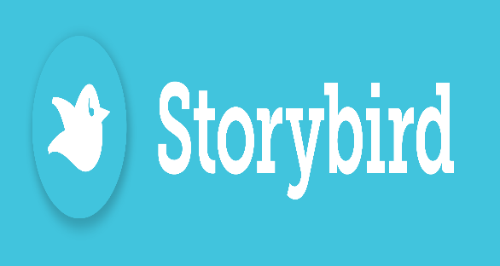
Etherpad

Etherpad.org
Etherpad text is synchronized as you type, so that everyone viewing this page sees the same text. This allows you to collaborate seamlessly on documents. Etherpad allows you to edit documents collaboratively in real-time, much like a live multi-player editor that runs in your browser. Write articles, press releases, to-do lists, etc. together with your fellow students or colleagues, all working on the same document at the same time.

Standard- CC.1.4.1.X
Write routinely over extended time frames (time for research, reflection, and revision) and shorter time frames (a single sitting or a day or two) for a range of discipline-specific tasks, purposes, and audiences.

Lino

http://linoit.com/home
Lino is a great service that provides its registered users with virtual “stickies” that can be placed on a canvas or bulletin board area. Both Lino users and non-registered guests can post stickies on the canvas. The great thing about Lino is that you can use it at three levels: public, limited access and private. It is collaborative, and has multiple uses in the classroom.

Standard - CC.8.5.6-8.B
Determine the central ideas or information of a primary or secondary source; provide an accurate summary of the source distinct from prior knowledge or opinions.

